Schedule 1
Yarm Gwanga, Child Care Service Fees and Charges – Effective 9 January 2023
Standard Fees | Bush Babies  (8 wks - 12 mths) | Gumnut Toddlers (12 mths - 2 yrs) | Kindy Koalas  (2 - 3 yrs) | Pre-School  (3- 5 yrs)
WEEKLY FEE  (5 days / 45 hours) includes lunch & afternoon tea | $615.00 | $615.00 | $615.00 | $590.00
DAILY FEE  (1 day / 9 hours) includes lunch & afternoon tea | $123.00 | $123.00 | $123.00 | $118.00
MORNING FEE  (8.00am - 1.30pm / 5 ½ hours) includes lunch | $90.00 | $90.00 | $90.00 | $80.00
AFTERNOON FEE  (1.30pm - 5.45pm / 4 ¼ hours) includes afternoon tea | $65.00 | $65.00 | $65.00 | $58.00

Other Fees and Charges
Occasional Care (not enrolled at Yarm).  Note: this fee applies to all rooms and sessions | $123.00
Overtime Charge  This fee is charged for every 15 minutes or part thereof after 5.45pm | $40.00
Security Bond/Deposit  Per child per enrolment | Remains at $200.00

Vacation Care Fees and Charges
Daily Fee | $70.00
Overtime Charge  This fee is charged for every 15 minutes or part thereof after 5.45pm | $40.00

Additional fees associated with the direct debit process are noted overleaf.

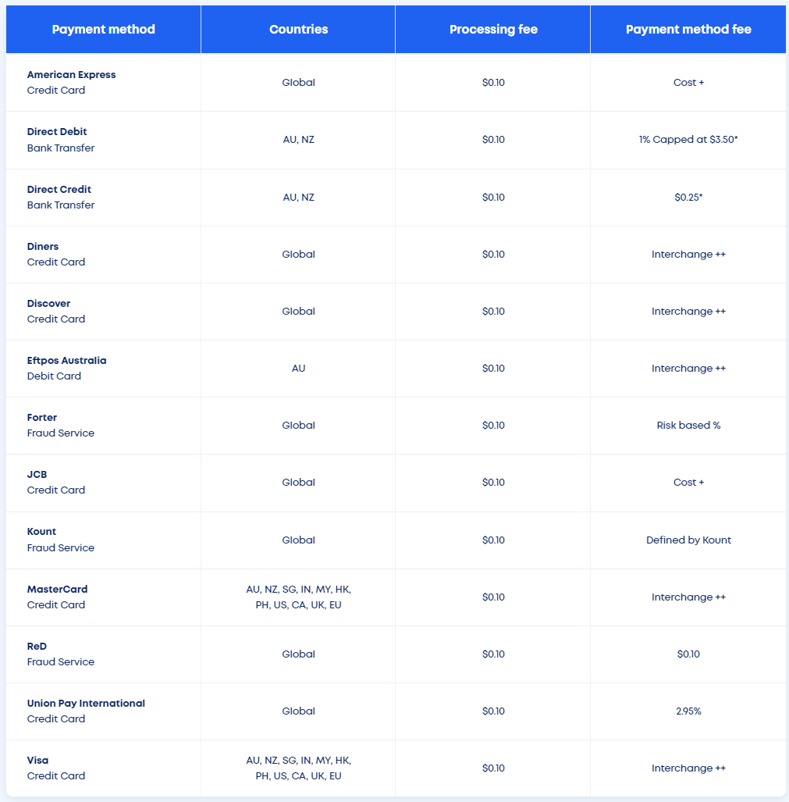
DIRECT DEBIT FEES
