Event Details and Registration Information
Copy and paste both columns below in to online event request form, and submit to Safety and Security
EVENT TITLE

NAME OF PERSON SUBMITTING

DATE OF EVENT

LOCATION OF EVENT

EVENT START TIME

EVENT FINISH TIME

EVENT PACK UP AND CLEAN UP TIME

NUMBER OF PEOPLE EXPECTED TO ATTEND

TYPE AND QUANTITY OF ALCOHOL

TYPE AND QUANTITY OF FOOD

FREE WATER AND AMOUNT

NAME OF RF/RA/RT ON DUTY

PHONE OF RF/RA/RT ON DUTY

NAME OF JCR SOBER REP/S (MUST HAVE RSA)

PHONE/S OF JCR SOBER REP/S

FULL DESCRIPTION OF EVENT

N.B. It is not permitted for any tent pegs or any other posts to be driven in to the ground without the express permission from FMS or Safety and Security.

Risk Assessment Details
Date of Risk Assessment
Risk Assessment Consultation Group | List the risk assessment team with the first person being the author of the risk assessment. N.B. A minimum of two people should be included in the risk assessment.
Event Details
Where alcohol is being served/supplied?
Is alcohol being served/supplied in standard measures?
Is a Liquor Licence being extended to UNE property for the event?
Will alcohol be sold at the event?
Is admission going to be charged for this event? Does admission include alcohol?
What measures do you have in place to deal with intoxicated and / or violent people?
Are there any entertainment or recreational activities/games/ sport at the event?
Is the event being held in a controlled area – where entry and exits points are monitored? Where/how?
Is the event BYO? N.B. this will not be approved.
Will Head of College be present at the event?
Event organisers understand that drinking games or other activities that promote rapid intoxication are prohibited?

With consideration to event features above, please assess listed hazards and specify controls that will be in place at your event. Add any additional hazards you can think of. Use the risk score calculator on the following page to assess risk.
Hazard | Inherent Risk Score | Proposed Controls | Residual Risk Score
Excessive alcohol consumption

Transport to and from event

Games and Activities at event

Ultraviolet light

Insects, spiders, dogs, snakes

Slips, trips, falls

Psychological

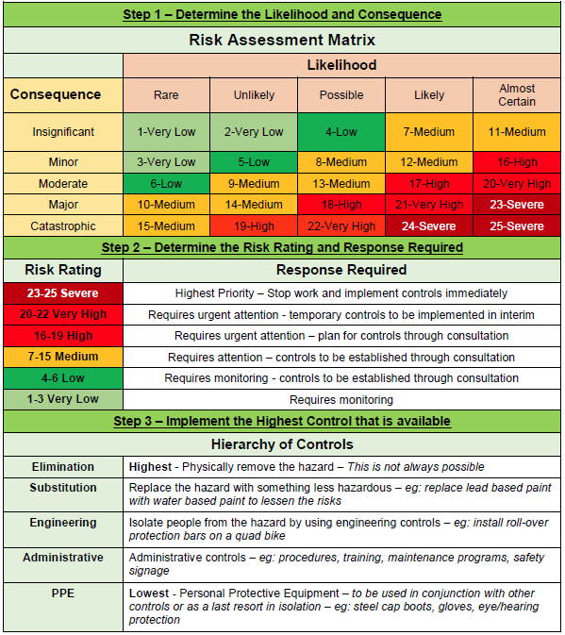

Sign Off
Sign off from risk assessment participants indicates agreement amongst the risk assessment team with the contents of this document. Sign off is also required by the person responsible for the control measures.
Name | Signature | Date

Head of College Review
The Head of College must review this risk assessment and ensure control measures are reasonably practicable. If a risk rating is identified as Very High or Severe the Risk Assessment MUST be reviewed by the WHS Team
Review | Response
Are planned control measures reasonably practicable?
Are planned control measures sufficient to mitigate risk (based on your knowledge, experience and review of this risk assessment)?
Are there any changes to planned control measures?
Are further controls required in the future?
Name | Signature | Date

Records Storage Instructions
A copy of all completed WHS F070 Risk Assessment Forms shall be submitted to Safety and Security via the Event Registration process.

